[Updated on 14-Apr-2021]
[User Guide]
[e-Mobile Leave]
Approver
[version 2.0.1.0]

Contents
Login 2
Dashboard 3
Change Password 4
How to Apply Leave? 6
How to Cancel Leave? 10
Check Leave Status 13
How to Approve/Resubmit/Reject Leave? 15
Approve One by One Leave Record 16
Approve Leave by Batch 19
Logout 22

Login

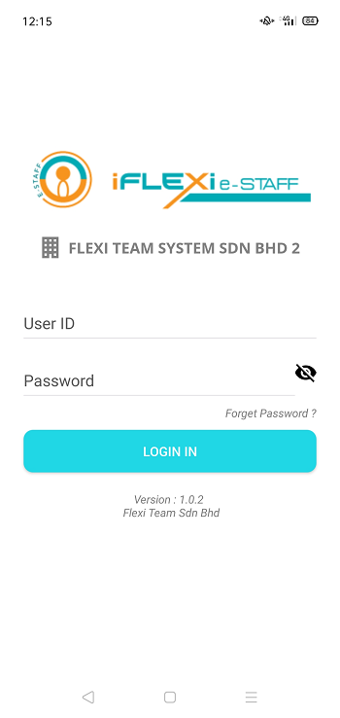
User ID: Your employee number.
Password: which is same as e-Leave system password
Click on “LOGIN” button.

Company Code: Please click here to enter your company code. Our support team will send you company code.
User MUST enter their company code when first time login to the ESS.

Dashboard
When login successfully, employee will redirect to “Dashboard”:
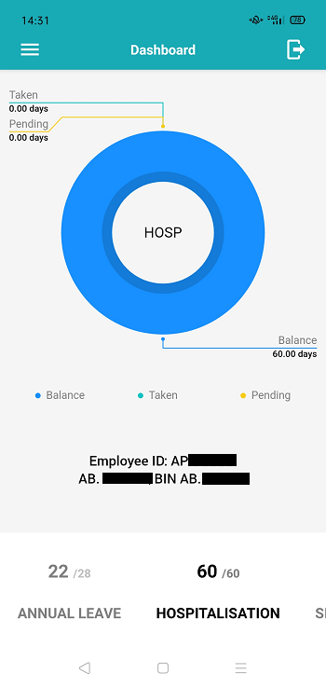
Pie chart will let you see Annual Leave, Hospitalization, and Sick Leave taken, pending and leave balance.

Click on “ANNUAL LEAVE” if you want to see annual leave taken, pending and balance.

Change Password
If user change password through their mobile phone, this new password will reflected in ESS system too.
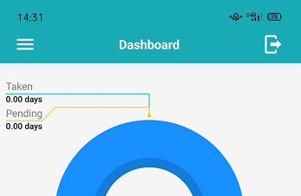
Step 1. Click this menu.

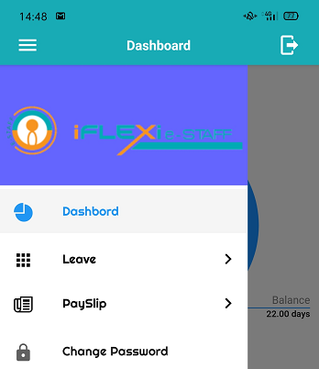
Step 2. Click “Change Password”

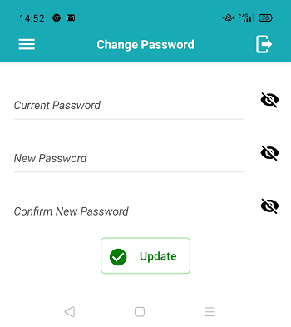
Step 3: Enter your current password and new password.
Step 4: Click on “Update” button.

How to Apply Leave?

1. Click this menu

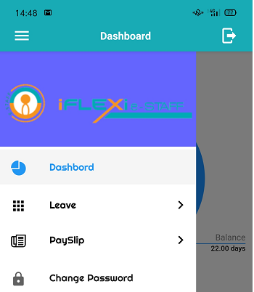
2. Click this menu

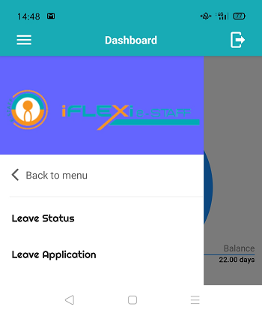
3. Click this menu

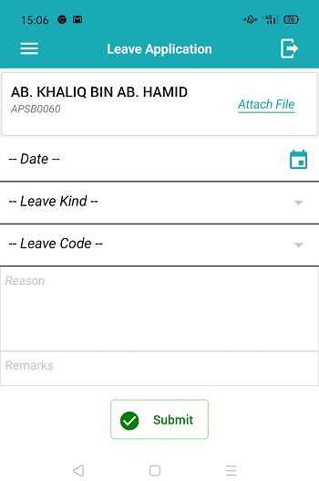
Step 1: Enter all your leave information here.
Step 2: Click on “Submit” button.
Click on “Attach File” if you need upload your supporting documents.

You will this message when apply leave successfully.
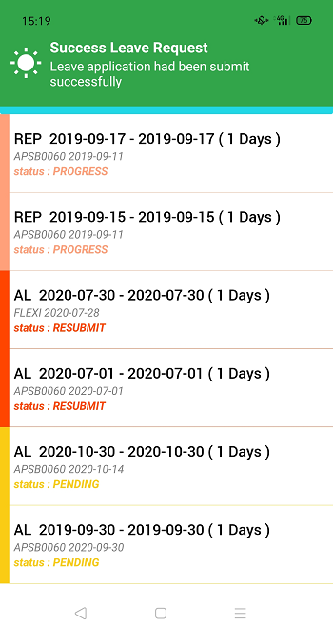
Your leave will appear on this screen and will be in “PENDING” status which show in yellow color.

How to Cancel Leave?
Step 1

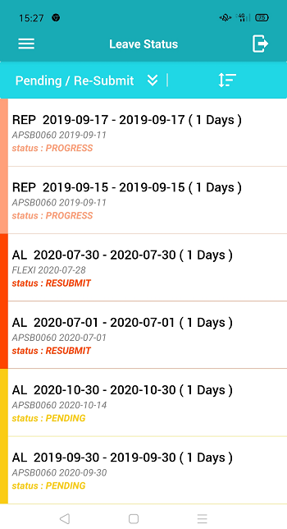
Step 2: Click on leave record which you want to cancel.
You can filter leave record according to leave status, just click on this icon.
Click here to sort your data.

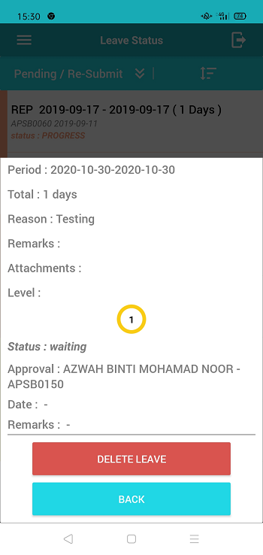
Step 3: Click on “DELETE LEAVE” button.

Check Leave Status
Step 1

How to Approve/Resubmit/Reject Leave?

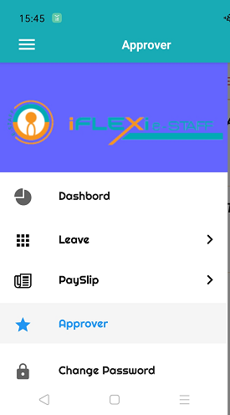
Approver Menu

Approve One by One Leave Record

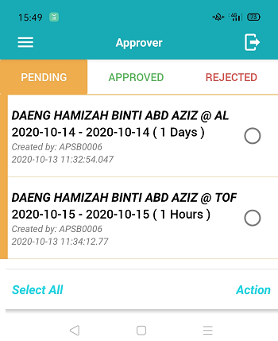
Step 1: Click the leave record which you want to take action.

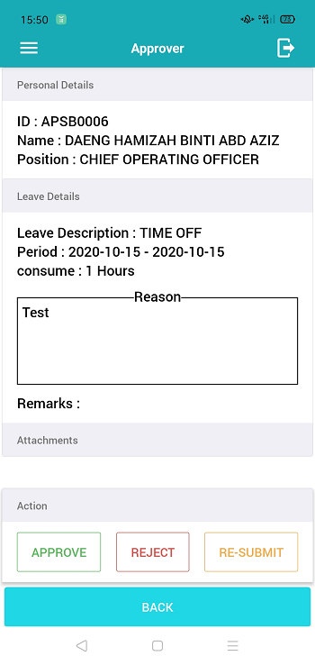
Step 2: Under “Action”, click either “APPROVE”, “REJECT” or “RE-SUBMIT” button.

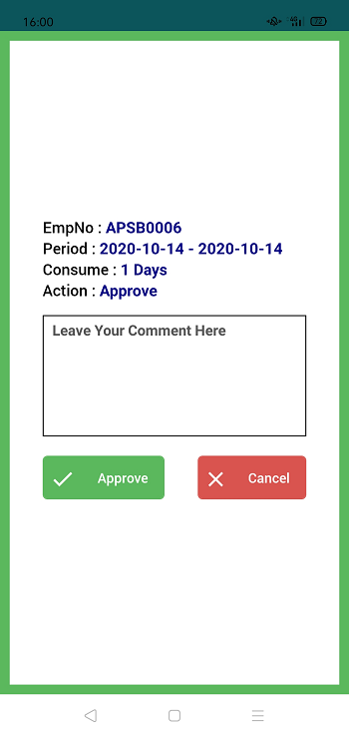
Step 3: Click on “Approve” button when you want to approve this leave application.
You MUST enter your comment here if you choose “Re-Submit” or “Reject” action.

Approve Leave by Batch

Step 2: Click on “Action” button.
Step 1:  all this radio button for those records which you want to take action.

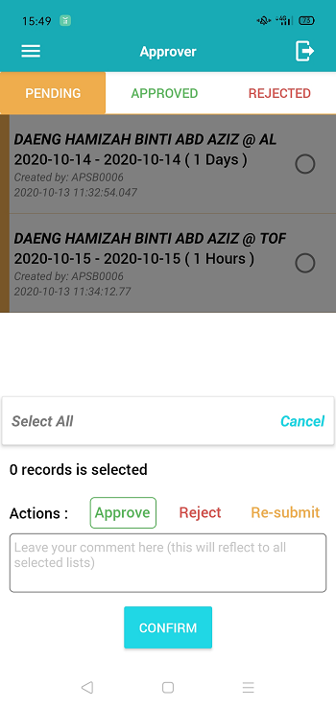
Step 3: Under this Actions, click either “Approve”, “Reject” or “Re-submit” action.
Approver must enter their reason here if they choose action of “Reject” or “Re-submit”.
Step 4: Click on “CONFIRM” button.

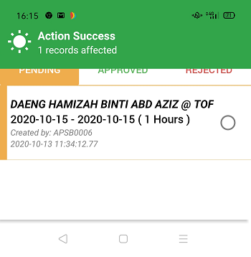
You will see this message when you approve successfully.
Record will disappear from this screen if you already take action.

Logout
Click this icon to logout from mobile apps.

