[Updated on 14-Apr-2021]
[User Guide]
[e-Mobile Leave]
Supervisor
[version 2.0.1.0]

Contents
Login 2
Dashboard 3
Change Your Own Password 4
How to Apply Leave on Behalf of Subordinate? 6
How to Cancel Leave? 10
Check Subordinate’s Leave Status 15
Search Subordinate’ Leave Record 16
Search by Staff Name 16
Search by Department 17
Logout 18

Login

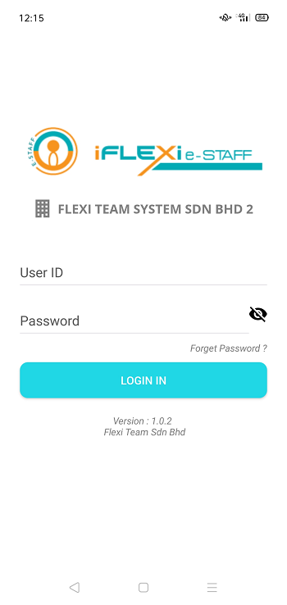
User ID: Your employee number.
Password: which is same as e-Leave system password
Click on “LOGIN” button.

Company Code: Please click here to enter your company code. Our support team will send you company code.
User MUST enter their company code when first time login to the ESS.

Dashboard
When login successfully, employee will redirect to “Dashboard”:
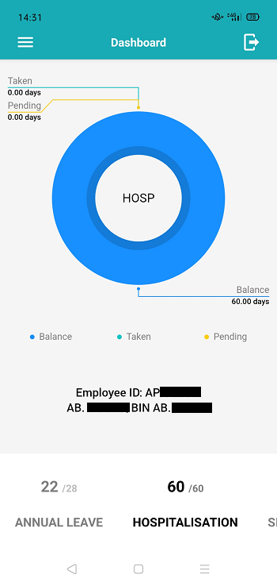
Pie chart will let you see Annual Leave, Hospitalization, and Sick Leave taken, pending and leave balance.

Click on “ANNUAL LEAVE” if you want to see annual leave taken, pending and balance.

Change Your Own Password
If user change password through their mobile phone, this new password will reflected in ESS system too.
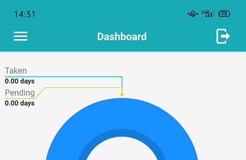
Step 1. Click this menu.

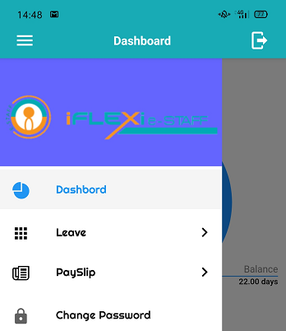
Step 2. Click “Change Password”

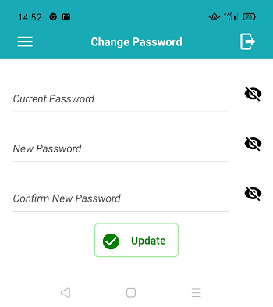
Step 3: Enter your current password and new password.
Step 4: Click on “Update” button.

How to Apply Leave on Behalf of Subordinate?

1. Click this menu

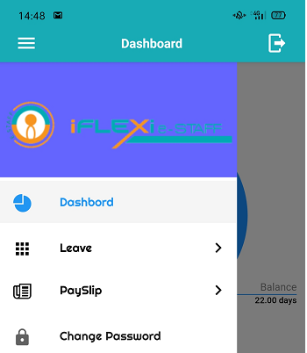
2. Click this menu

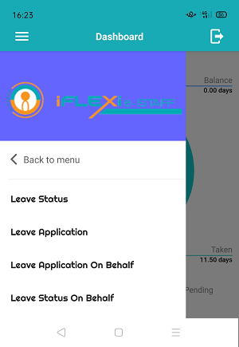
3. Click this menu

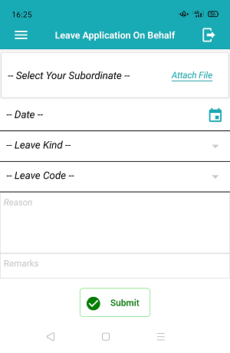
Step 2: Enter all your leave information here.
Step 3: Click on “Submit” button.
Click on “Attach File” if you need upload your supporting documents.
Step 1: Select subordinate’s name here.

You will this message when apply leave successfully.
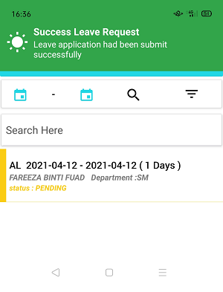
Your leave will appear on this screen and will be in “PENDING” status which show in yellow color.

How to Cancel Leave?
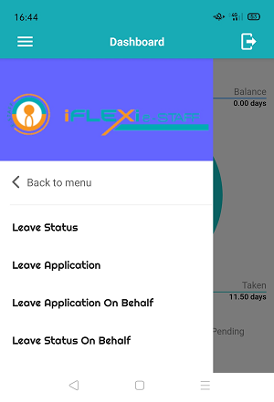
Step 1

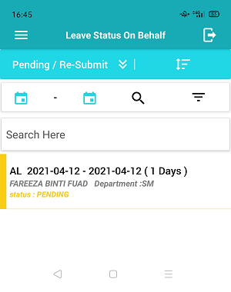
Step 2: Click on leave record which you want to cancel.
You can filter leave record according to leave status, just click on this icon.
Click here to sort your data.

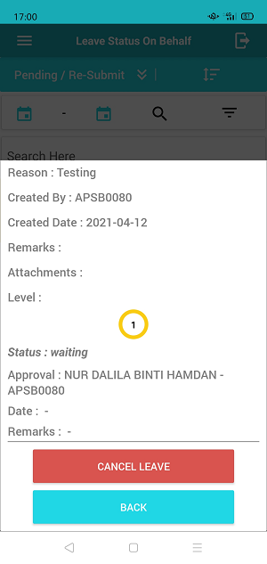
Step 3: Click on “CANCEL LEAVE” button.

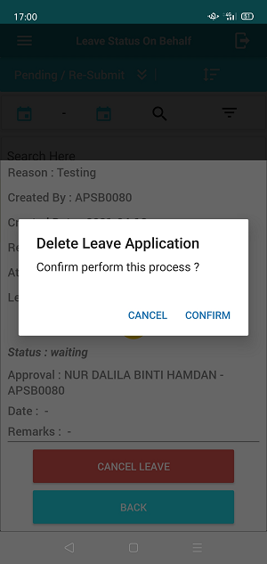
Step 4: Click “CONFIRM” if you confirm to cancel this leave.

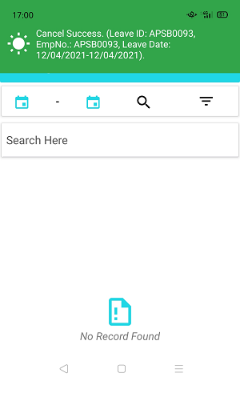
System will prompt this message if you cancel leave successfully.

Check Subordinate’s Leave Status
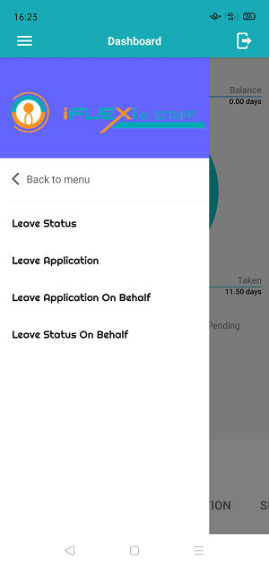
Step 1

Search Subordinate’ Leave Record

Search by Staff Name
System allow supervisor search respective staff by enter staff name at the top of leave record listing, refer to below screen shot:
Go to Menu -> “Leave” -> “Leave Status on Behalf”
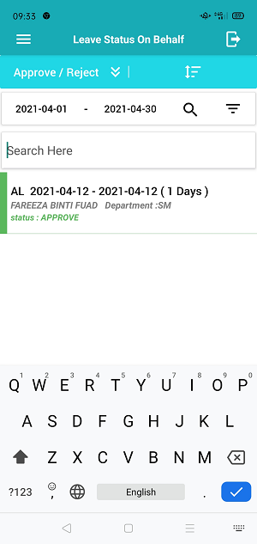
Enter staff name who you want to search at this text box

Search by Department
Supervisor can search their subordinates’ leave record status by select their department, refer to below screen shot:
Go to Menu -> “Leave” -> “Leave Status on Behalf”
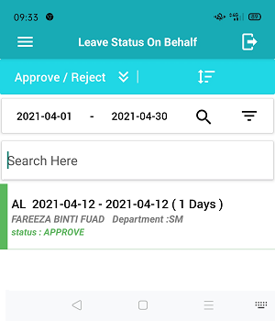
Step 1: Click on this icon.
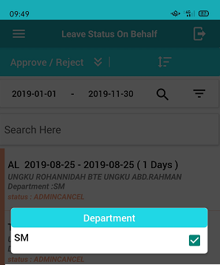
Step 2: Department listing will appear here.
Step 3:  box which department you looking for.

Logout
Click this icon to logout from mobile apps.

